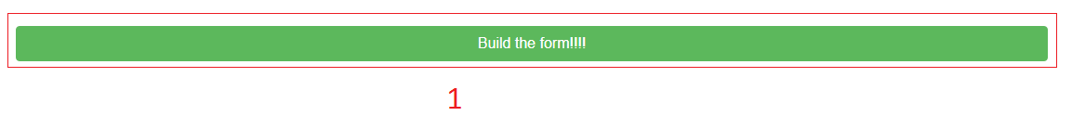

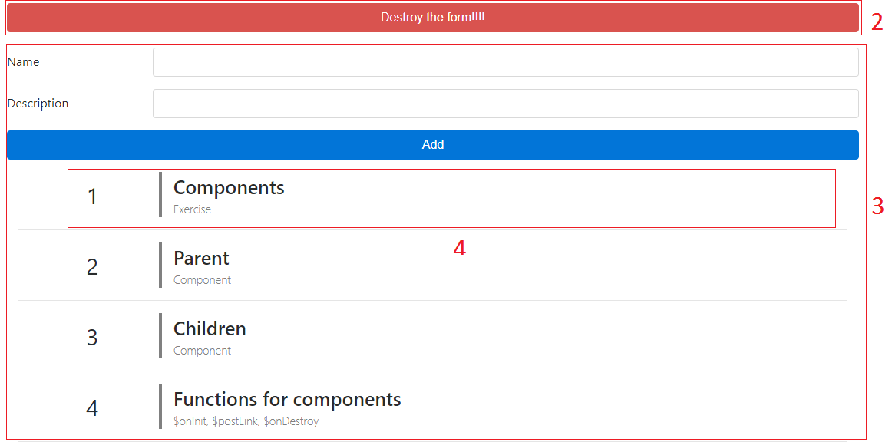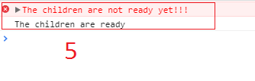

Instructions:

* Create a button which builds the form component - 1
* When the form is built, change that button so you can Destroy the form – 2 (You have to use the function $onDestroy, you can put a console.log when this is destroyed)
* Create 3 different components, the first one will be the parent component which contains its children – 3, The second one will be the form component, and the third one will be every element that you add – 4.
* The form component should add to a list a new object which contains a name and a description.
* Use $postLink to know when the children were loaded (you can show a console.log or an alert for this) - 5